How to make speaker to produce sound by CHIP

- Objective
In this tutorial I will show you how to connect a speaker to your CHIP. What we plan to do is safely connect a speaker with a mini amplifier to the CHIP with as few components as possible. Once we have the electronics put together on the breadboard, I will show you how to control them easily using Python to make the speaker to produce sound.

- Equipment
CHIP, breadboard, voltage regulator, speaker, mini amplifier,voltage booster, and a few cables.
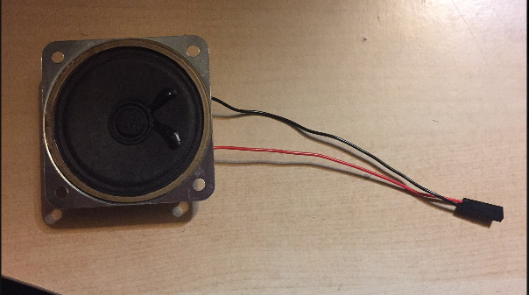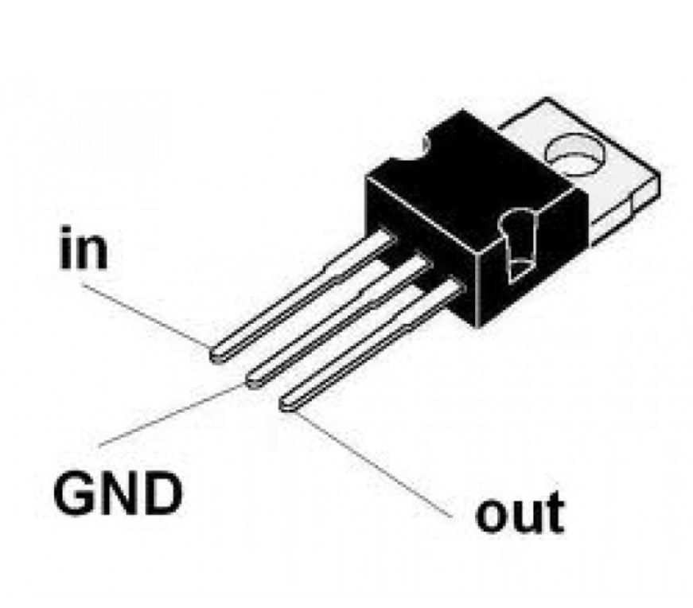
Speaker Voltage Regulator

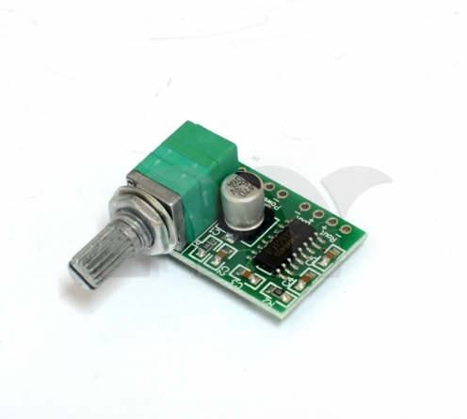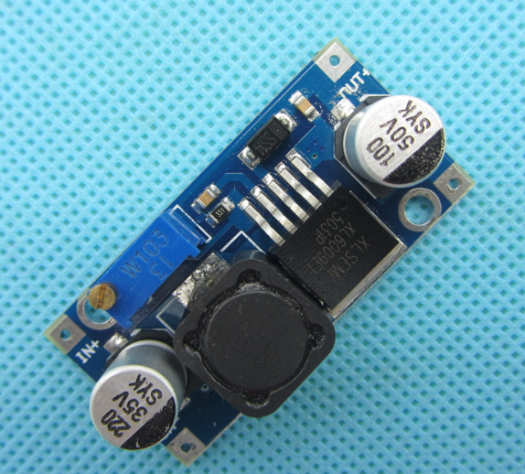
Mini Amplifier Voltage Booster

- Connection of Mini Amplifier
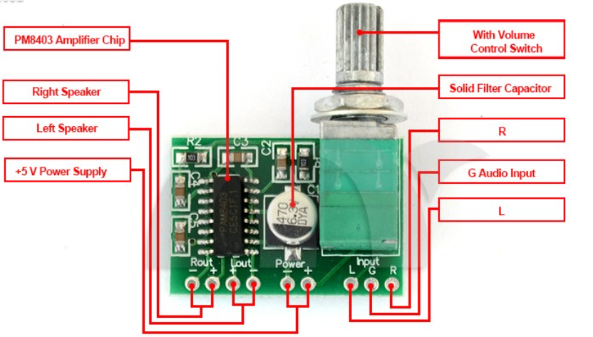
Layout of Amplifier

-Connect the speaker to either “Rout +/-” or “Lout+/-”. (We only need one of them)
-Connect “Power-” to the ground of voltage regulator
-Connect “Power+” to the output of voltage regulator
-Connect Input L to pin “HP L” of the CHIP
-Connect Input G to the ground of the CHIP

- Connection of Regulator

-Input: Connect to voltage booster
-GND: Connect to both voltage booster and “Power-”of the mini amplifier
-Output: Connect to “Power+” of the mini amplifier

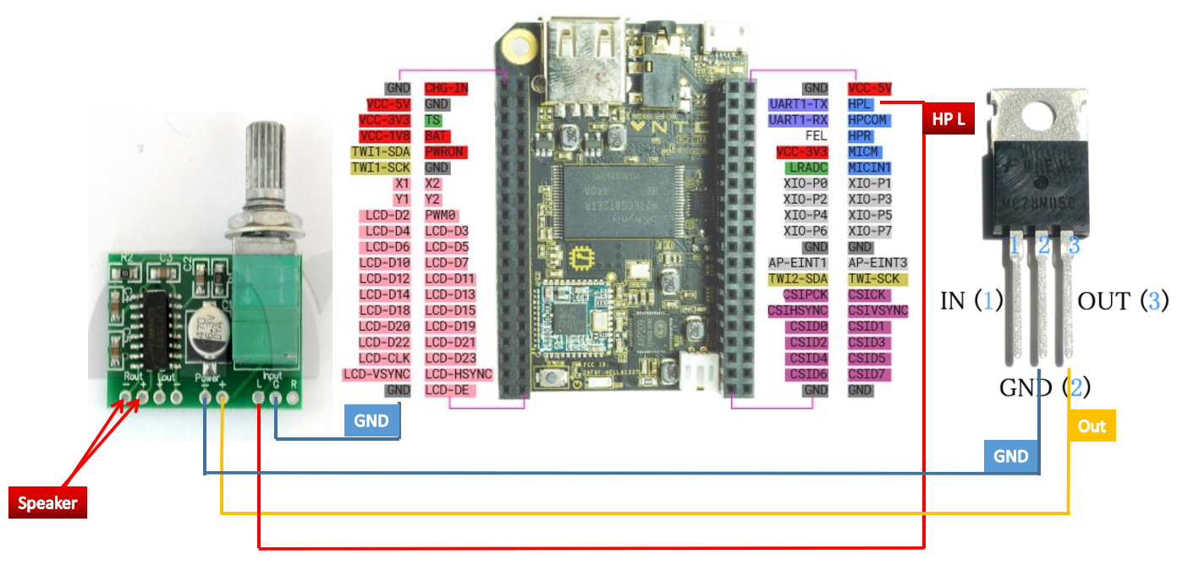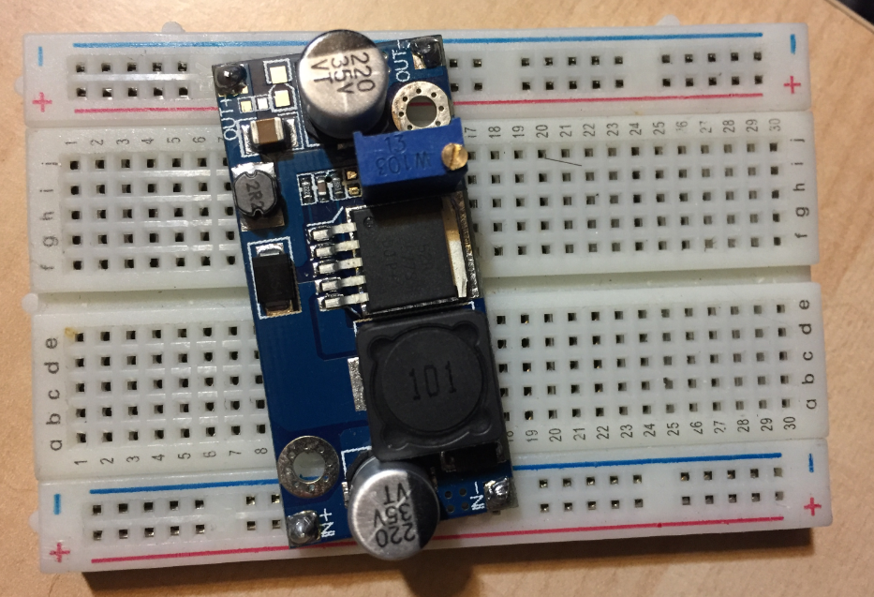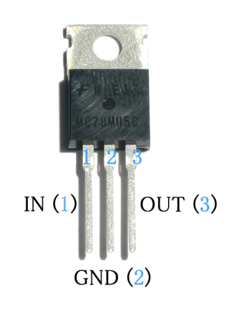
IN
GND
Out+
Out-

(You will finish assembling the circuits after following the above steps.）

- Testing

1. Festival Text to Speech
The first speech package I tried was Festival. It worked fine and produces a voice like a rough sounding robot.
Install Festival with:
sudo apt-get install festival
Try out Festival with any words, for example:
echo “Hello romibo” | festival --tts

2.Espeak Text to Speech
Espeak is a more modern speech synthesis package than Festival. It sounds clearer but does wail a little.
Install Espeak with: sudo apt-get install espeak
Test Espeak with: English female voice, emphasis on capitals (-k), speaking slowly (-s) using direct text:-
sudo espeak -ven+f3 -k5 -s150 "Hello romibo"

- Reference

Text to Speech Content:

http://elinux.org/RPi_Text_to_Speech_(Speech_Synthesis)

